SQL ASSIGNMENT 1

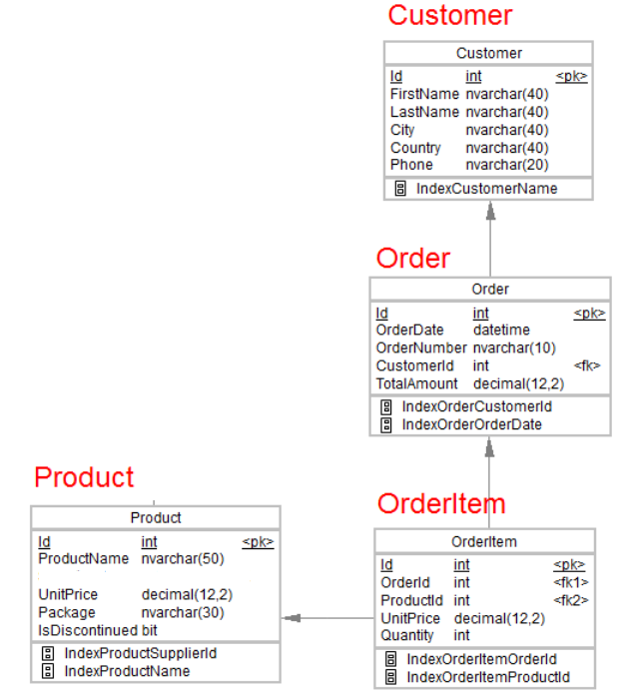

1.Desgin the above database with following table by applying Primary key and foreign key

2.Insert Records in all tables

3.In Customer table FirstName Attribute should not accept null value

4.In Order table OrderDate should not accept null value.

5.Display all customer details.

6. Write a query to display Country whose name starts with A or I

7. Write a query to display whose name of customer whose third character is i.

**Creating database**

Creating database shop

**Creating tables**

* Creating tables by applying Primary key and foreign key.

Customer table

Created graphically

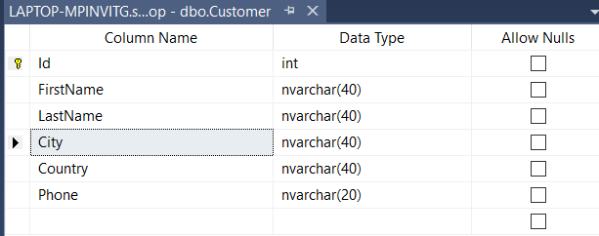

Order table

Created by using query

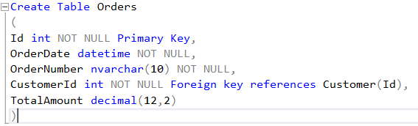

OrderItem table

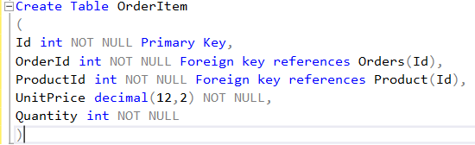

Product table

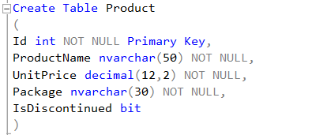

**Inserting Records**

Customer table

Query:

Insert into Customer (Id, FirstName, LastName, City, Country, Phone) values (1,'Ritu','Kanse','Mumbai', 'India',9876547410)

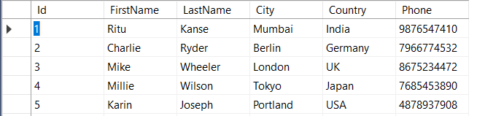

Order table

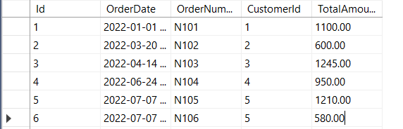

OrderItem table

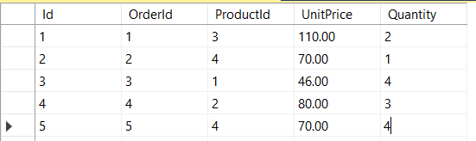

Product table

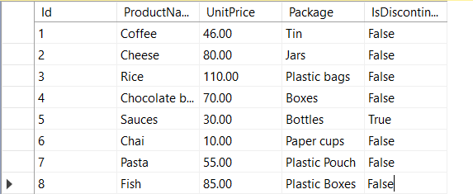

**Displaying all customer details.**

Query: select * from Customer

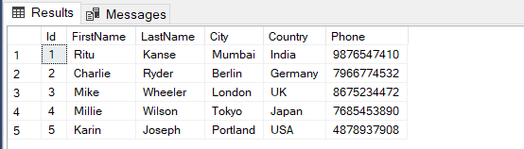

Write a query to display Country whose name starts with A or I

select Country from Customer

where Country LIKE '[ai]%'

select Country from Customer

where Country LIKE 'j%' OR Country LIKE 'I%'

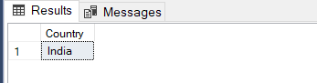

Write a query to display whose name of customer whose third character is k.

select FirstName from Customer

where FirstName LIKE '__k%'

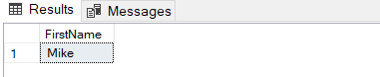

Create Table Orders

(

Id int NOT NULL Primary Key,

OrderDate datetime NOT NULL,

OrderNumber nvarchar(10) NOT NULL,

CustomerId int NOT NULL Foreign key references Customer(Id),

TotalAmount decimal(12,2)

)

Create Table Product

(

Id int NOT NULL Primary Key,

ProductName nvarchar(50) NOT NULL,

UnitPrice decimal(12,2) NOT NULL,

Package nvarchar(30) NOT NULL,

IsDiscontinued bit

)

Create Table OrderItem

(

Id int NOT NULL Primary Key,

OrderId int NOT NULL Foreign key references Orders(Id),

ProductId int NOT NULL Foreign key references Product(Id),

UnitPrice decimal(12,2) NOT NULL,

Quantity int NOT NULL

)

Insert into Customer (Id,FirstName,LastName,City,Country,Phone) values (1,'Ritu','Kanse','Mumbai', 'India',9876547410)

Insert into Orders (Id,OrderDate,OrderNumber,CustomerId,TotalAmount) values (1,'2022','N1',1, 1165)

select * from Customer

select Country from Customer

where Country LIKE 'j%' OR Country LIKE 'i%'

select FirstName from Customer

where FirstName LIKE '__k%'